32/40

Chapter 4 Assignment

Review Questions 1, 2, 4, 7, 10, 16, 17, 18, 21, 23 and 24 on pages 280 – 281

For garden glory 5 entities in first table 9 in the new one

1. Name the three stages in the process of developing database systems. Summarize the tasks in each.
   * + ***Requirements analysis stage, system users are interviewed and sample forms, reports, queries, and descriptions of update activities are obtained.***
     + ***Component design stage, the data model is transformed into a database design.***
     + ***Implementation stage, the database is constructed in the DBMS and populated with data; queries, forms, and reports are created; apps are written; and all these are tested.***
2. What is a data model, and what is its purpose?

***A data model is a representation of the content, relationships, and constraints of the data needed to support the system requirements.***

1. Skip
2. What is a use case, and what is its purpose?

***Use Cases are descriptions of the ways users will employ the features and functions of the new information systems. Use Cases provide sources of requirements and can also be used to validate the data model, the database design, and the actual database implementation.***

1. Skip
2. Skip
3. Define the term *entity* and give an example other than those used in this book.

***An entity is something that users want to track. Some examples would be a fast food restaurant wanting to keep track of their SALES, EMPLOYEE_PHONE_NUMBER, and FOOD_WASTED (includes expired or damaged food so they keep track of how much money they are losing).***

1. Skip
2. Skip
3. Define the term *identifier* and indicate which attribute defined in your answer to question 9 identifies the entry.

***Attributes that name, or identify, entity instances.***

1. Skip
2. Skip
3. Skip
4. Skip
5. Skip
6. Define the terms *maximum cardinality* and *minimum cardinality*.

***Maximum cardinality is the maximum number of entity instances that can participate in a relationship instance. Minimum cardinality is the minimum number of entity instances that must participate in a relationship instance.***

1. Draw an IE Crow’s Foot E-R diagram for the entities DEPARTMENT and EMPLOYEE and the 1:N relationship between them. Assume that a DEPARTMENT does not need to have an EMPLOYEE but that every EMPLOYEE is assigned to a DEPARTMENT. Include appropriate identifiers and attributes for each entity. ***See file Ch4Q17.*** You are showing possible value in the entities, not the identifiers and attributes. In Department, have DepartmentID as the identifier. Possible other attributes would be department name, department location. For Employee, possible identifier would be EmployeeID. Other attributes: first name, last name, address, city, state, zip
2. Define the term ID-*dependent entity* and give an example other than one used in this text. Draw an IE Crow’s Foot E-R diagram for your example. ***With an ID-dependent entity, the identifier of the entity includes the identifier of another entity. A Manufacturer can make many vehicles but a vehicle must have a manufacturer. See file Ch4Q18.*** OK
3. Skip
4. Skip
5. Define the term *associative entity*, and give an example other than one used in this text. Your example should start with a N:M relationship between two strong entities and then be modified by an additional requirement. Draw IE Crow’s Foot E-R diagrams for both your N:M relationship and for the relationships among the three entities that include the associative entity. ***An associative entity is used when a pure N:M relationship cannot hold attributes that are describing aspects of the relationships between two entities.*** Missing the ER diagrams
6. Skip
7. What is an exclusive subtype relationship? Give an example other than the one shown in this book. Draw an IE Crow’s Foot E-R diagram for your example. ***With exclusive subtypes, a supertype instance is related to at most one subtype.*** Missing the diagram
8. What is an inclusive subtype relationship? Give an example other than one shown in this chapter. Draw an IE Crow’s Foot E-R diagram for your example. ***With inclusive subtypes, a supertype instance can relate to one or more subtypes.*** Missing the diagram

Garden Glory project on page 285

For A, diagram the 5 entities that have been defined in the SQL on page 232. These 5 entities were all “ready” to be implemented in a relational database; however do not include foreign keys in the diagram unless they are a part of the identifier (foreign keys are not appropriate on a logical model). You do not need to state your cardinality justifications. ***See file Garden Glory part A.***

On the diagram, my only comments pertain to the relationships lines. There are no id-dependent entities, hence all of the relationship lines should be dashed (they are non-identifying relationships)

For B, complete an ER diagram that includes the new requirements as described. You do not need to state your cardinality justifications. ***See file Garden Glory part B.***

The relationship between Owner_Property and the subproperties would be 1:M and not M:N

How about equipment repairs?

No need to relate employee to equipment (but relate equipment to Training). Would you agree that a job (i.e. Property_Service) could involve multiple pieces of equipment?

Here’s my diagram:

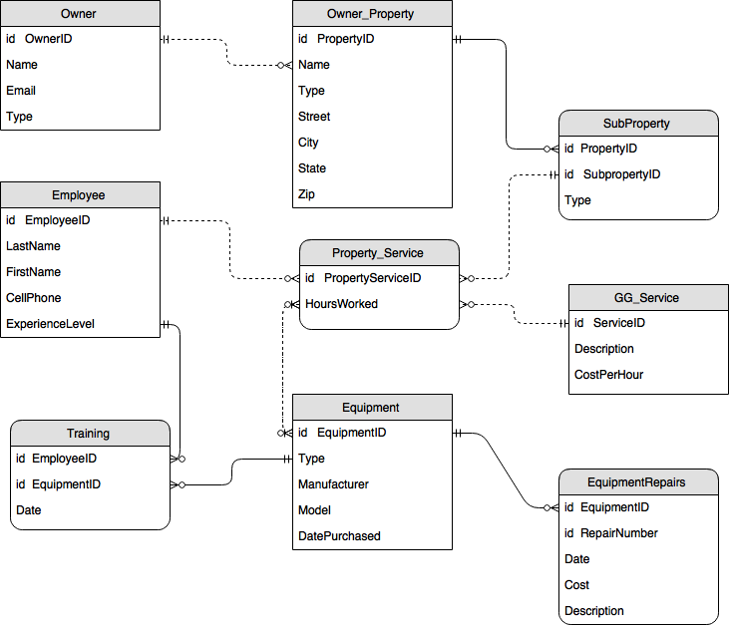

Answer C. In the real world, how would you go about ascertaining if your design plan was correct? ***Asking the person who asked me to design the database about the current design of the database. Revise the database until they are satisfied.*** Ok